TabBar

Exercise #01

Flutter Developer Bootcamp

# **Purpose**

This Exercise defines a TabBarExample widget that displays a tab bar with three tabs ("Chat", "Camera", and "Settings"). Each tab corresponds to a different screen. It creates a tabbed interface for navigation.

# **Problem**

This Exercise creates a tabbed interface with three tabs (Chat, Camera, and Settings), each displaying different content when selected.

# **How to Solve**

1. Checkout the workshop from Git Repo:

git clone -b <user-branch> <repo-URL>

2. Open the root folder inside VS Code

3. To build the app click the run option in the main method { }

4. Create a tabBar with 3 icons

5. Each screen contains different colour

# **You Will Achieve**

This Flutter code creates a simple tab bar interface with three tabs: Chat, Camera, and Settings. Each tab has an associated icon. When you run this code, you'll get a UI with a grey app bar titled "Home" and a tab bar beneath it with the specified icons. The body of the app changes according to which tab is selected.

Here's what each widget achieves:

1. **DefaultTabController**: This widget manages the state necessary for a tab bar and its associated tabs. It requires a length parameter specifying the number of tabs and an initialIndex parameter specifying which tab should be selected initially.
2. **Scaffold**: This widget provides a framework for implementing the basic material design visual layout structure of the app. It contains the app bar and body content.
3. **AppBar**: This widget represents the app bar that appears at the top of the Scaffold. It contains a title and, in this case, a TabBar as its bottom.
4. **TabBar**: This widget displays a horizontal row of tabs. It takes a list of Tab widgets as its tabs parameter. Each Tab can have an optional icon.
5. **TabBarView**: This widget displays the content corresponding to each tab. It takes a list of child widgets where each child corresponds to a tab.
6. **Tab**: This widget represents a single tab in the TabBar. It can contain an icon, a text label, or both.
7. **Container**: This widget is used to contain the content for each tab. It provides a way to add padding, margins, or decoration to its child.
8. **Centre**: This widget centres its child widget horizontally and vertically within itself.
9. **Text**: This widget displays a string of text.

In summary, this code creates a tabbed interface with three tabs, each displaying a different coloured container with text indicating the name of the tab.

# **Screenshots**

## **Expected Output**

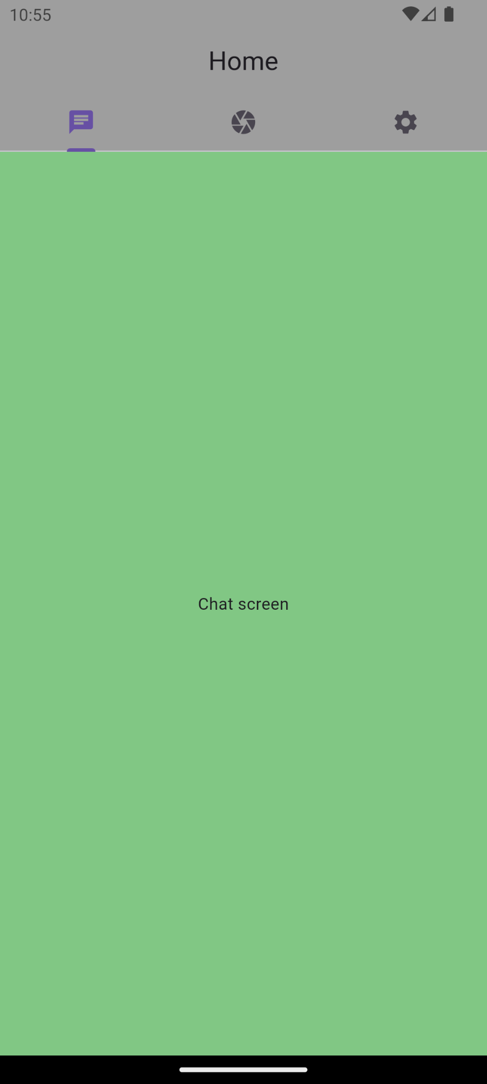 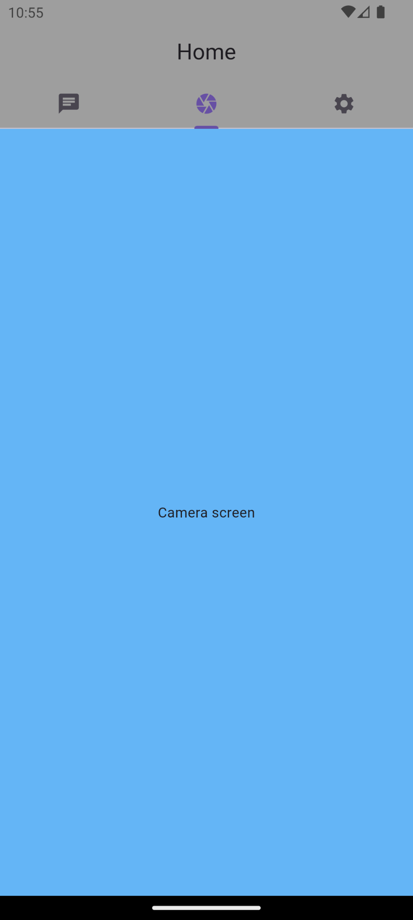 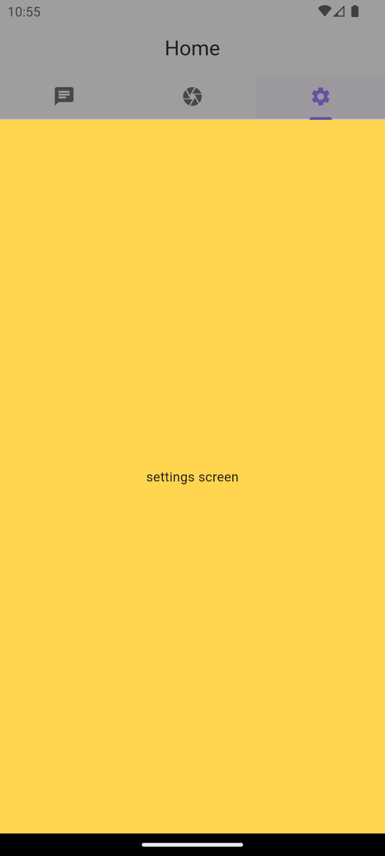

# **How to submit your Exercise**

Push your project back to the same git branch using command:

<command name>

# **Happy Coding!**